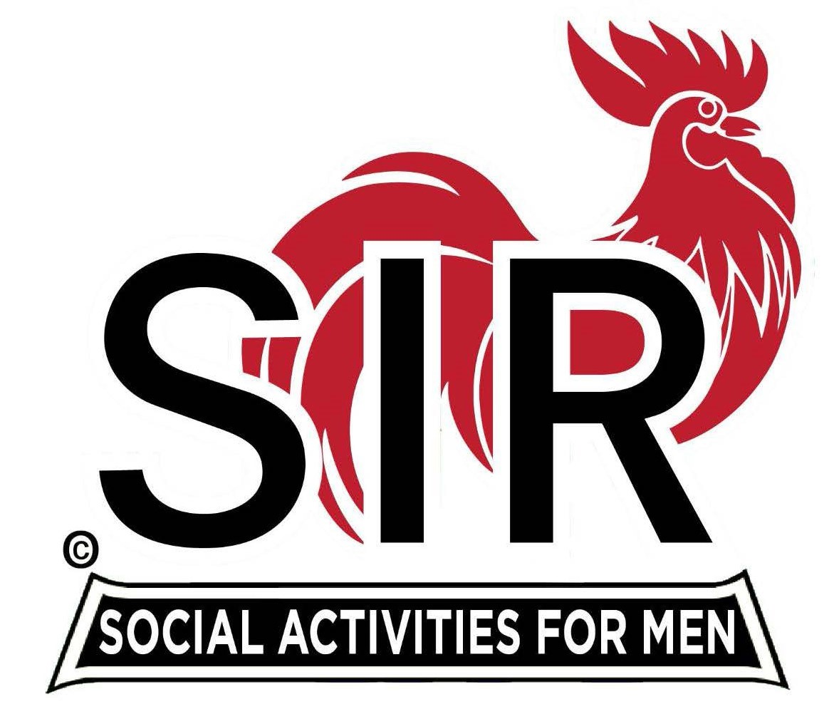
Las Trampas Branch 116
BEC Meeting Agenda
January 15, 2024, 9:15 AM at Boundary Oak
DRAFT
The Mission of SIR is to enhance the lives of our members through fun activities, events and luncheons while making friends for life.

9:15 am Call to order; Secretary, Paul Ramacciotti – Confirm quorum and
Approval of November 20, 2023 BEC meeting minutes

9:20 am Standing Reports

- Treasurer – Charlie Guthrie

- Luncheon Report – Dennis Snarr

- January 15 Boundary Estimated Count

- Membership – Alan Fitzgerald
  - Remembrance – Jim Nachtweih

- RAMP Department Head Reports:

- Recruitment – Don Schroeder
  - New members: Gary Halick sponsored Tom Walsh and Vincent (Tony) Latini
- Activity Coordinator – Mike Ward
- Member Relations -
- Publicity – Robin Lemmo

9:40 am Little SIR Updates – Paul Russell

- Speaker Info – Frank Falzone/Duffy Jennings
- Birthday Boys – December and January

9:50 am Updates & New Business

- Branch 116 Activity Survey
- Sunshine Report – New process
- Lunch Seating
- Recruitment Ideas

10:15 am Adjourn: Lunch Preparations

